Quick Start Guide to
Attending High School Mountain Bike Races
(for Parents and Riders)

Welcome to High School Mountain Bike Racing!
To help you get started with the basics of organizing for the race season, NICA has assembled this Quick Start

Guide. It’s based on 10 years of parents and kids asking coaches, “What am I supposed to bring?” “Where am I supposed to go?” “When do I need to be there?” We hope that you find this guide helpful as you prepare for your first racing season. If you have any additional questions please visit the League

Preparing for a League Race

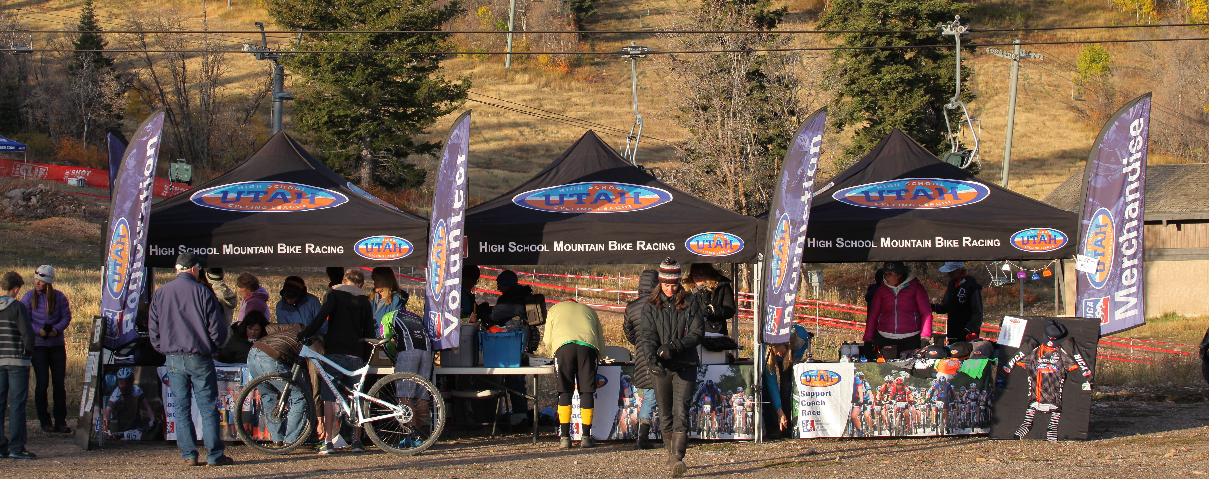
League Registration: All League riders must be “race ready” in the pit zone to race in the first race. That means waivers signed, NICA and League fee paid. Race fees can be paid online prior to the event or on-site at each race.

Registration, Volunteer Check In and Merchandise Tents

Plates & Bibs: Each registered rider receives both a number plate with timing chip and a bib number to be used for the entire season. Number plates are affixed to the rider’s bike with twist ties and you should be able to read the number clearly when you stand in front of the rider. Bib numbers are pinned to the back of rider’s jerseys and should be readable from behind to other riders.

Can you read that number on the picture to your right? Neither can timing. Take a step back from your rider and see if you can read their number before letting them race.

Lost Plates: you PURCHASE a replacement number plate for $10 at the league registration tent.

Parent comment- Take off your race plate right after the race and keep it in your race bag. The most common way to lose a race number? Blown off a car-mounted bike while driving
Race Cancellations - Races can be cancelled due to weather conditions such as rain, snow, heat, etc. If a race is cancelled it will be posted on the League website and announced via email to all League coaches, riders, and registered families, etc.

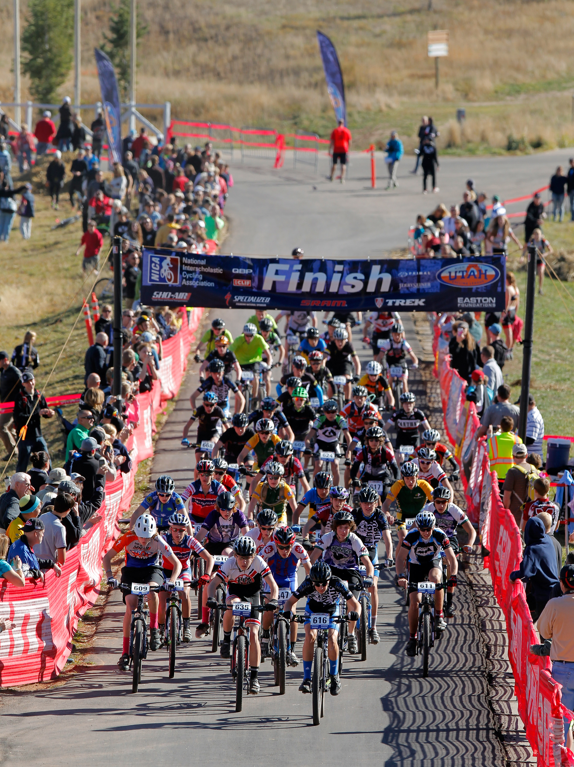
League Races - The League prides itself on producing high quality, professionally-produced events. These events can sometimes be larger than people expect. League races are open to all riders and teams registered with the League. In addition to the riders and coaches, each team generally has several volunteers to help with setup and logistics. League staff and a small army of volunteers provide setup and logistics support for everything from parking and registration, to course setup and marshaling, to awards ceremonies and race results. With all of the riders, coaches, volunteers, spectators, sponsors, and supporters, the total number of participants at a Utah League race will be between 1,500-2,000. The better prepared you are for the event the more fun you will have. Parent Comment- “I didn’t know the races were so big!”

What to Pack: Parent Comment- “spare towels for cleanup, camp chairs to sit in, warm up blankets if it's cold, clothing to stay warm when you're waiting around, rain gear, thermoses of coffee, and hot chocolate, water, food and snacks, ice, change of clothing, bike parts, sunscreen/hats/sunglasses, garbage bags, paper towels, first aid kit and camera
Sophomore Boys Start Soldier Hollow 2013 Photo: Steve Wilson

Riding Gear and Equipment – The basics every rider must have for a day of racing include shoes, socks, riding shorts, jerseys, gloves, water bottles, and helmet. In addition to these basics, extra riding layers, sunglasses and hydration packs (e.g. Camelbacks) are pretty standard.

Weather – Weather can be quite variable. Wind, rain, and snow, to intense heat, sun and dust are all possible conditions that you might experience. Bring extra layers, sunglasses, sunscreen, umbrellas, etc. Parent Comment- “Bring towels and plastic bags for wet clothes.”

Environmental Conditions – Mountain biking is an outdoor activity and the environmental conditions for each venue can vary. Be prepared.

Food and Beverage Service – On-site food and beverage services are available at most races.

Caffeine Rule – Caffeinated products of any sort are banned during race-day for all competitors. . Riders are responsible for knowing the ingredients of their energy gel, drinks and bars. See the rulebook for a complete list of banned substances.

Race Day
Utah League Race Schedule: see Race Flyers for specific wave schedules, directions, parking details, course specifics, and maps. http://www.utahmtb.org/races/ - raceslanding

Arrive with plenty of time to warm up and attach your race plate. Be at staging 15 minutes before you start time. We encourage teams and riders to stay through the ceremonies to support their fellow athletes. Student Comment- “Race day is bigger than just a race, it is about sharing a great experience with hundreds of others riders, coaches and families.”

Helmets – HELMETS ARE REQUIRED FOR ALL RIDERS AT ALL TIMES while riding during events – this means during races, pre-rides, warm-ups, and even casual riding at the race site.

Music Players – Student-athletes are not allowed to race or ride with headphones or other portable musical devices. Headphones are permitted while riding a stationary trainer.

Positive Sporting Attitude – Parents, coaches, and student-athletes are expected to display an excellent sporting attitude during all League events and should treat other riders, coaches, spectators, and officials with respect. Fair play and respectful, kind, supportive behavior is expected of all League athletes. Profanity in any situation is not acceptable.

Restrooms – Restrooms and/or porta-potties will be available at all race locations. Please use these facilities and respect the venue.

Team Radio Channels – Families using Motorola type radios should be aware that teams are assigned frequencies. These frequencies should be reserved for important team communication. Ask your coach for you team’s channel.

Dogs on Leash – If dogs are permitted at the race venue, they must be kept on a short leash at all times.

Pack Out All Trash – Help the League keep costs down by packing out all your trash that does not fit in the bins provided. Do not pile up trash around park trash bins.

Event Zones

ARCHES HEALTH PLAN FIRST AID ZONE – The first aid tent is the place to come for minor injuries. Medical staff will be available for injuries like cuts, scratches, bump, bruises, and etc.

In addition, the Utah League also has 2 or more EMTs on site for emergency medical services and/or evacuation. Please make sure you know where this zone in case of emergency. If you get injured, or are assisting with someone who is injured please report the injury to the nearest course marshal who can assist you . Parent Comment- “As a mom I was glad to see EMT services.”

SPECIALIZED PIT ZONE – The Pit Zone area is designated for team setup and preparation. The Pit Zone has limited parking based on the venue. Typically teams set up an Easy Up Tent, Bike Rack, wind trainers, etc. to help riders prepare for races.

SRAM NEUTRAL SUPPORT ZONE – Mad Dog Cycles and The Bike Shoppe will have a full-service bike maintenance and support vehicle in the Neutral Support Zone, they will have several mechanics there to help you as well. Additionally, they will have donated products from SRAM & Maxxis (chains, tubes, tires, cables, etc) to help students repair bikes and get out racing.

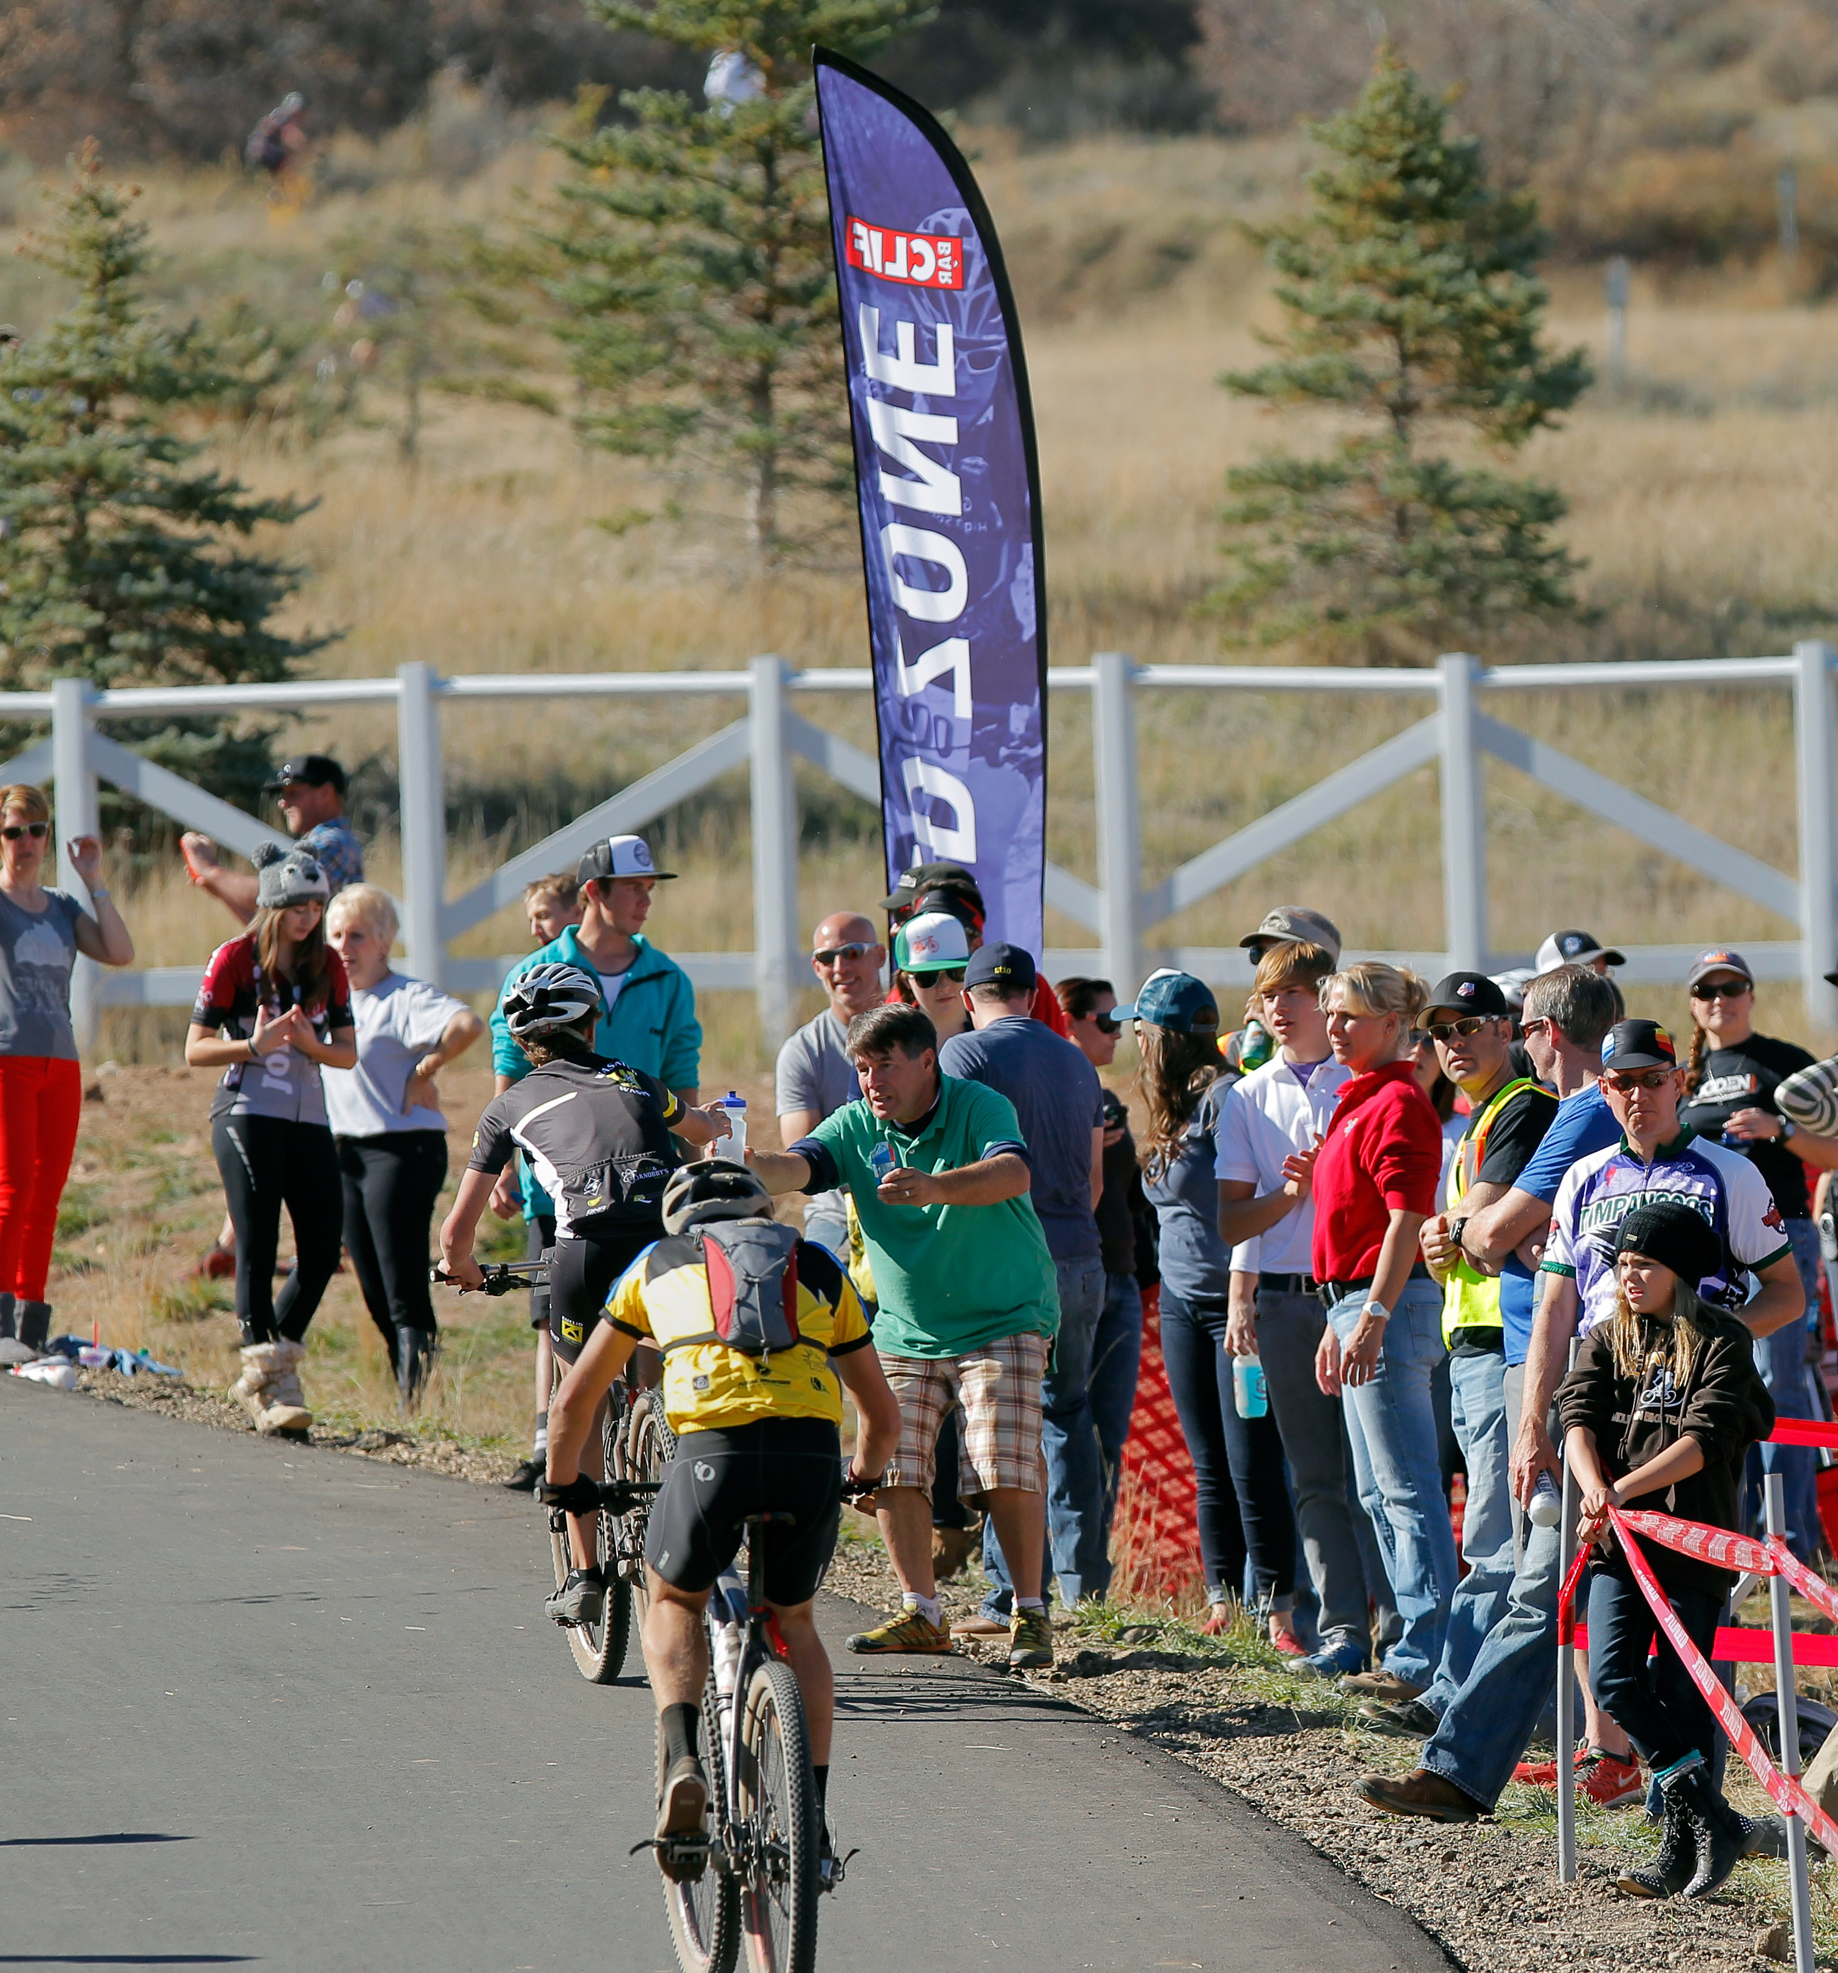
CLIFF FEED ZONE – The Feed Zone is an area designated for providing riders with hydration and nutrition during the races in a safe, controlled manner. Designated Coaches, riders, and volunteers can enter the feed zone and hand off food and bottles, sun glasses, jackets, etc. to riders as they pass by. There is donated Cliff and Gu product for racers to use during their race. Feed zone marshals will monitor products. This is the only area on course where support can be provided. See the NICA Rulebook for detailed Feed Zone rules.
Cliff Feed Zone
Photo:Steve Wilson
SCOTT BIKES – demo bikes and fun

TREK SPEED ZONE – this is where timing happens at the finish line.

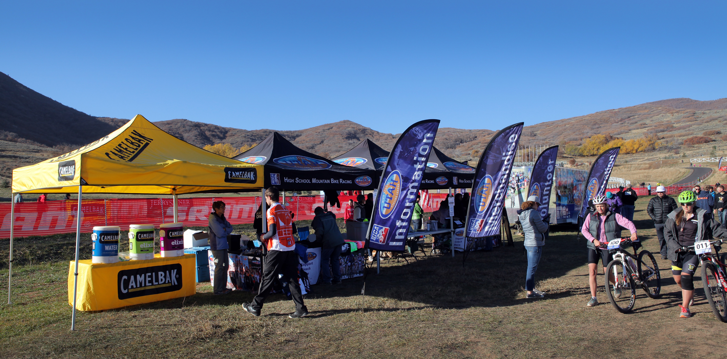
CAMELBAK HYDRATION STATION – free hydration (both water and Brew) provided in the Camelbak tent next to registration tents.
Camelbak, Registration, Merch, Volunteer Check in Tents
Photo:Steve Wilson

Racing

Helmets – HELMETS ARE REQUIRED FOR ALL RIDERS AT ALL TIMES while riding during events– this means during races, pre-rides, warm-ups, and even casual riding at the race site.

Pre-Race Preparation – Proper sleep, nutrition, hydration and training is the best way to prepare for a race. Eat a good meal with liquids prior to race. Visit the Neutral Support Zone for a quick bike setup and tune.

Warming Up – Warming up generally includes stretching, visualization, spinning, etc. Be careful not to expend too much energy while warming up – try to remain relaxed and focus on your goals.

Pre-riding the Race Course – Pre-riding is encouraged to learn the course, plan your race strategy and reduce accidents. If you are going to pre-ride make sure to leave yourself enough time and conserve your energy.

Race Starts – Racers are gathered at the start zone and grouped into waves according to their category based on their race number. Races are started in waves with at least 5minutes between each wave to spread out the riders on the course.

Pacing – Starting safely and in control will allow you to establish a stronger pace. Staying in control of your heart rate and breathing will allow you to stay in control on your bike. Controlling the bike will allow you to ride faster. Student Comment- “If you have a lull in your energy but have been at practice, have eaten and drank like you were told, you will come back.”

Passing – Passing during races is a critical area of riding etiquette. It is the responsibility of all riders to call out when passing someone. Riders who are being passed must yield to the rider passing them. Coaches Comment- “Hold your Line, be assertive with commands’tracking left, tracking right,’ before you pass on the left or right”

Finishing – Finishing strong is important for a successful race. Pacing yourself in order to have energy left to cross the finish line is not always easy to do. Having the energy for a final kick at the end of a race can mean the difference between a personal best and a place on the podium. You need the energy to finish strong and in control. Coaches Comment- “No matter what, each race experience is important and is a learning experience. Set aside time to reflect on your performance, what you could have changed, how to prepare, how to focus, what will go differently next time.”

Time Limit Rule – Because of time limitations and risk management factors, there is a time limit rule that governs all racers. Racers that do not meet time limits are pulled from the race but are scored in their current PO. Course closures may be announced at anytime and are determined day-of based on factors including but not limited to weather conditions, length of course, and difficulty of course.

Sweeps – Volunteer sweepers are roving course marshals who may be seen on bikes on the race course during the actual races. These race officials monitor riders' behavior and respond to emergencies should they occur. Riders and parents are expected to follow instructions provided by these individuals during races.

Race Rules and Governance - The Chief Referee governs the race and has the final say on all rulings. Parent Comment- “there are rules, but more than that there is a sense of honor and goodwill to handle the gray areas. It takes a few races to figure that out.”

Results and Awards

Results – Race results are posted in the Pit Zone after each race is completed, and each racer receives a time and finish ranking. If you see any errors in the results let your team coach know and he or she will discuss the issue with the timing officials. PLEASE DO NOT LEAVE THE RACE BEFORE CHECKING RESULTS – PROTESTS INVOLVING THE PODIUM MUST BE SUBMITTED AT THE RACE PRIOR TO AWARDS.

Awards – Awards are given for the individual top finishers in each category and for top combined team scores. It might mean a later departure, but staying for the award ceremony is a great way to support riders.

Tips for Spectators

Watch What Other People Are Doing – It takes a few races to take in the full experience. Experienced riders and volunteers know the ropes; where to get the best views, where to take the best pictures, when to cross the course, where to stand for the starts and finishes, etc. Pay attention and ask more experienced spectators for advice and you will have a better experience. Parent Comment- “Parents need to know where is it ok to stand and watch, where the start and finish lines are, when and how to cross the race course, things to say and do as riders pass by, how to be positive and support all of the teams and riders, until the last rider crosses the finish line.”

Listen to Course Marshals – Course Marshals use whistles to signal that riders are approaching – please yield course to riders at all times. Listen to Course Marshals’ instructions for crossing the course and enjoy the action.

Things To Say and Do – Always try to encourage your riders with your comments, and be courteous, if not encouraging, to other riders and spectators. Cowbells are fun and motivational and are available at the League store.

Authorized Riders on Course – During a race, no one may ride (or run) on the course in the proximity (within 200 meters) of any competitors.

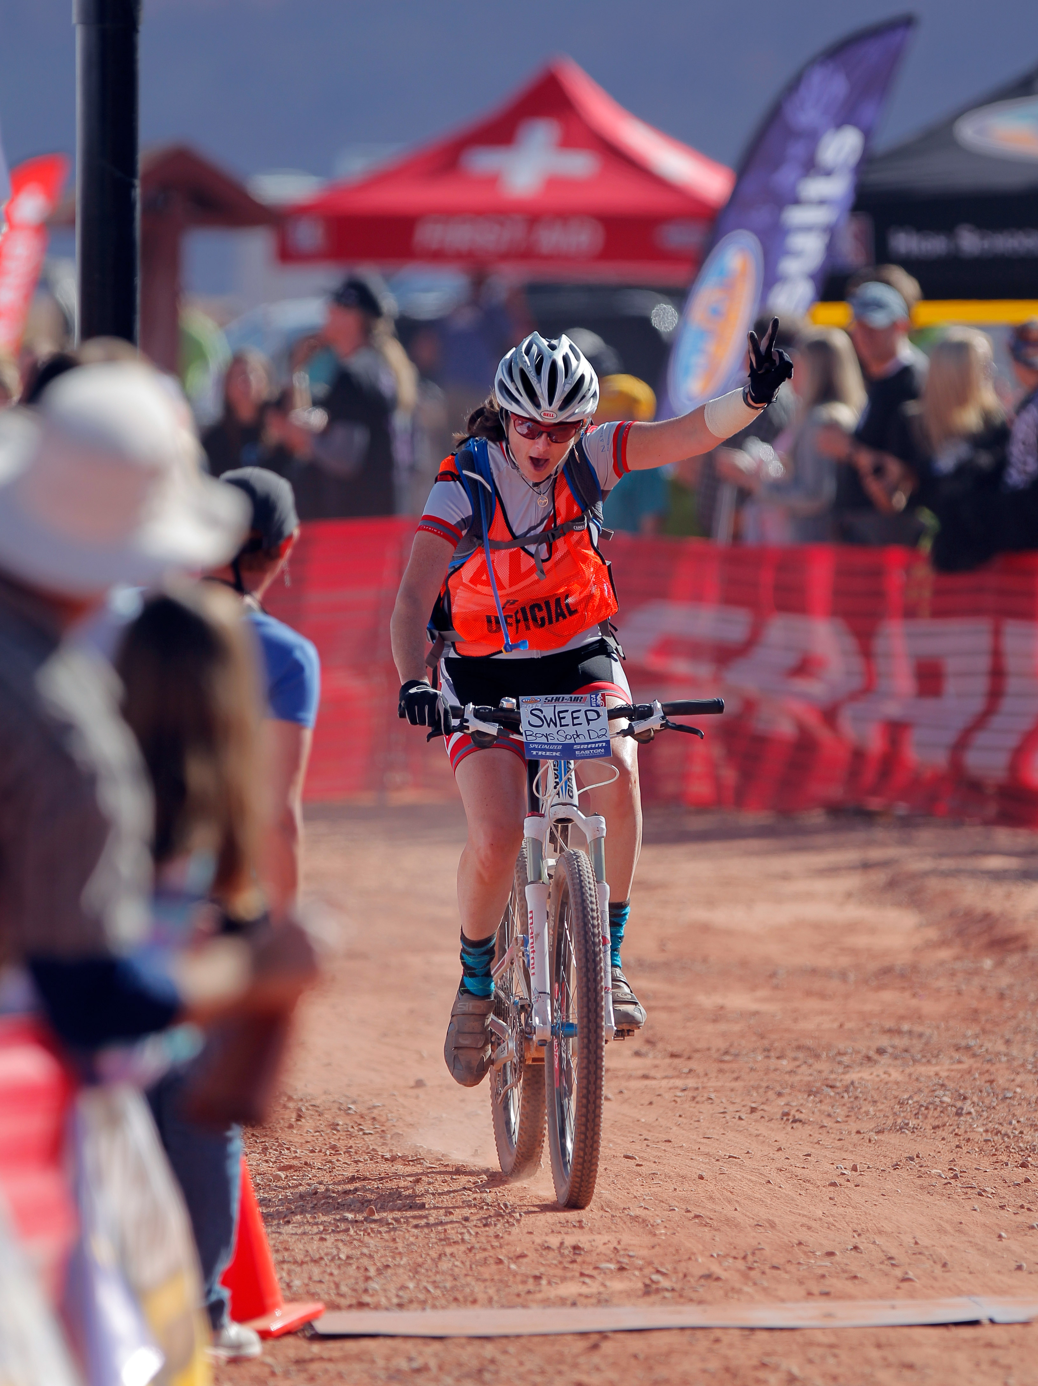
Volunteering

Volunteering formally and informally is highly encouraged and there are many ways to get involved. Informally, when you are at League races, any time you can lend a hand to assist riders, coaches, parents, and volunteers helps make the whole event more enjoyable for everyone. Formally, you can sign up in advance to be a League volunteer and choose what you would enjoy doing or you can sign up on the day of the event. There are many volunteer opportunities from course setup and takedown, course marshalling, timing, race sweeps, photography, etc. Go to the League website to learn more. Parent Comment- “Everyone else is working. I know nothing about this. What can I do to help?”
Volunteer Sweep
Photo:Steve Wilson

Rules

The official NICA Rulebook has a complete listing of all rules and consequences for rule violations. The Rulebook also details procedures for addressing rule violations, scoring and timing issues, etc. The NICA Rulebook is downloadable from the League website.

