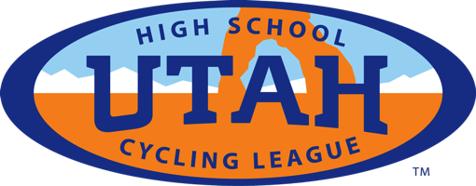

Join xxxx High
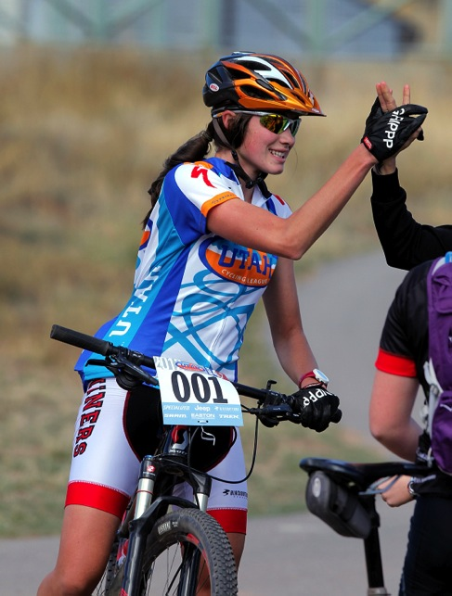
Mountain Biking Team

Girls & Boys Wanted!
No Experience Necessary! Beginner to
Advanced welcome.
Come have fun and join the new team!

Contact: xxxxxxxxx
email

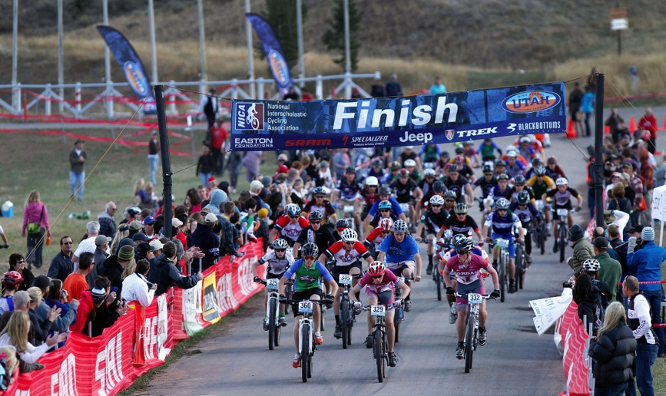

Brenna Eggan Varsity Girls Overall Champion

JV Boys start at State Championships 2012

For more information about high school mountain biking visit www.utahmtb.org

